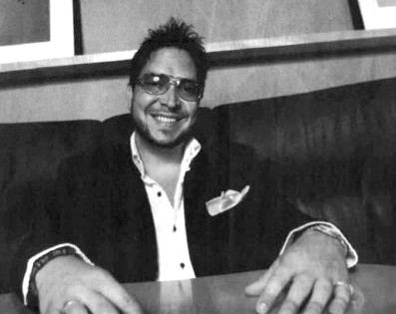Sergio Navarretta
SERGIO NAVARRETTA began Platinum Image Film in 2000 with a view to producing entertaining and enlightening creative projects for a wide audience. Since then, he has directed and produced a number of short films, two documentaries, music videos and two feature films.

Navarretta’s passion for film was nurtured under the guidance of renowned acting coach Rose Dubin, as well as Hollywood actor Nick Mancuso. He produced and directed: the award-winning short, Over a Small Cup of Coffee, which premiered at the historic Egyptian theatre in Hollywood; the documentary Going to the Movies, which premiered at the Academy of Canadian Cinema & Television screening series; the comedy Serena de Bergerac; the dramatic film, Il Bagno (The Bath), which was accompanied by a live string ensemble at its world premiere at the Toronto Italian Film Festival and the award-winning short, The Fortune Cookie. Commedia, a film that combine opera and acrobatics, airs on BRAVO! TV.

Navarretta is proud to have directed his debut feature film Looking for Angelina, which tells the true story of Angelina Napolitano, an Italian immigrant woman who murdered her abusive husband on Easter Sunday, 1911 in Sault Ste Marie’s little Italy. After a successful premiere at the Montreal World Film Festival, the film screened at festivals around the world, winning 3 awards including a special recognition award in Genoa, Italy, by a prestigious jury that included Academy Award-Winning director, Juan Bautista Stagnaro. Looking for Angelina was released theatrically in fifteen cities across Canada, and ranked among the top 5 for Canadian films in release. Most recently, he received the prestigious international Award of Recognition from Italian Women of the World in Bologna, Italy, for his work on the film, by Mr. Tonino Lamborghini.

Navarretta just completed his latest feature, The Colossal Failure of the Modern Relationship, starring Enrico Colantoni (Just Shoot Me, Veronica Mars, Flashpoint, Remedy) and David Cubitt (Traders, Medium), a comedy shot entirely in Niagara’s wine country region. The movie is expected to release this Fall.

Most recently, Navarretta and service executive produced for Canada, Andron for AMBI Pictures, starring Danny Glover and Alec Baldwin. He is also the Canadian service producer on a CGI, animated feature film Arctic Justice starring Jeremy Renner, James Franco, Anjelica Huston, John Cleese, and Heidi Klum.

Selected Credits – Director - Film

2015 | The Colossal Failure of the Modern Relationship – Feature Film | Director
In development | Roosewood | Director
 | The Reunion – Feature Film | Director
 | Chasing George – Feature Film Director

2013 | What’s on Your Plate? – TV Series Pilot | Director
2011 | Forever Para Ti, Alyssa – Music Video | Director
 | The Fortune Cookie - Short film | Director
 | Serena De Bergerac - Short film Director
2010 York Victim Services – PSA Director
By Way of Prague – Movie Promo Director
2009 | Foco Meo – Theatre Production | Director
2008 | Angelina Found – Documentary Feature  2007 OMNI Television Broadcast | Director
2006 | Looking for Angelina – Feature Film | Director
2005 | Commedia – BRAVO! FACT – Short | Director
2004 | Doorsteps Neighbourhood Services - PSA | Director
2003 | Going to the Movies - documentary feature | Director
2002 | Il Bagno – Short Film  Toronto Italian Film Festival | Director
2001 | Over a Small Cup of Coffee – short (LAIFA/TIFF) | Director

LOOKING FOR ANGELINA– feature film Director

2005 Montreal World Festival
2005 International Film Festival of India 2005 Cinefest Sudbury
2005 Shadows of the Mind Film Festival 2005 Bay Street Film Festival
2005 Cimameriche Film Festival, Genoa Italy 2005 Quintus Italian Film Festival, Montreal 2006 Mumbai International Film Festival
2006 CINEPLEX CINEMAS, Toronto – Theatrical Release
2006 OMNI TELEVISION – Broadcast
2007 OMNI TELEVISION – Broadcast
2010 PBS: WNED BUFFALO / TORONTO – Broadcast
2010 Buffalo International Film Festival
AWARDS:

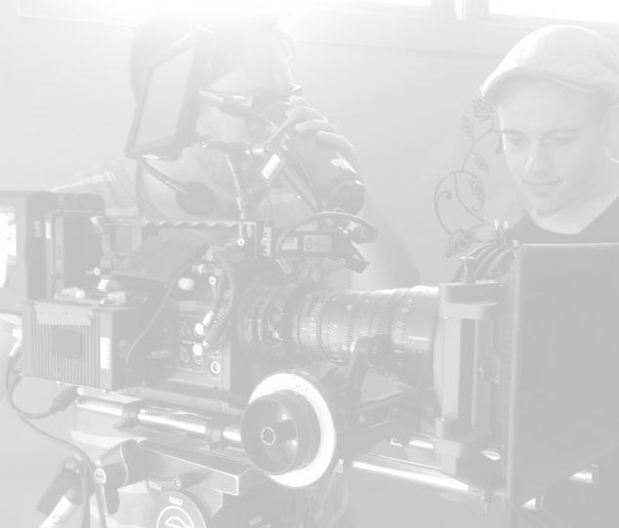The Fortune Cookie
Best Shorts Film Competition, La Jolla, CA – “Award of Recognition”
We Like ‘em Short Film Festival, Baker City, Oregon – Nominated for:
“Best Cinematography”

Looking for Angelina
Quintus Film Festival, Montreal – “Best Feature Drama”, “Award of Distinction” Cimameriche Film Festival, Genova Italy
- “Special Recognition Award”
Italian Women in the World, Bologna, Italy – “Award of Recognition”

Over a Small Cup of Coffee
Los Angeles Italian Film Awards 2001 - “Special Recognition Award”
The Colossal Failure of the Modern Relationship- Castlepoint Numa Award

EDUCATION
York University 1991
Seneca College acting program 1998 Terragon Theatre Director’s Intensive w/ Richard Rose 2012 Screenwriting Intensive Workshop with Tom Schlesinger 2012

Founding member of Sensational Elora, Founding member and Vice Chair of IACHC (Innisfil Arts Council), member Arts & Letters Club

