
Members Meeting Minutes
Date Thursday December 13th 2012 - 7 p.m.
Venue – Community Room, Innisfil Police Station, Innisfil Beach Road
Attendance:
Name | Present | Regrets
JD - Jane Dewar |  | X
SN - Sergio Navarretta | X
ES - Erin Scuccimarri | X
SS - Sam Stephen | X
RC - Robin Crowder | X
MG - Monica Goodfellow | X
JL - Jeanette Luchese | X
KW - Karen Wild | X
RB - Rebecca Breedon | X
Donna Wice | X
Carol Thompson-New Member | X
Alexander Doan-New Member | X

- Welcome by CHAIR

SN Opened the meeting at 7.20pm, Quorum was confirmed by MG.

- REVIEW WITH MEMBERS HOW TO VOTE
MG confirmed use of voting cards.

- Treasurers Report

Current Balance $1,689.26

Action: All invoices must be made out to IACHC.

Richard Lardener confirmed as accountant.

- Standing COMMITTEE RePOrts

Community Engagement – JL presented an update to the membership
document attached.

Committee waiting for procedures for working wit key organisations from
Membership Standing Committee.

South Simcoe Arts Council – have a tentative agreement brought over from
the Steering Committee – needs to be firmed up.

Membership – MG presented an update to the membership document
attached.

Motion to approve Jane Dewar, Erin Scuccimarri and Sam Stephen as
members of the Membership Standing Committee (MG) / Seconded (SN)
Carried

Motion to extend complimentary membership by 4 months to April
2013 (MG) / Seconded (SS) Carried

Action: SN invited all to introduce at least 10 new members to the group
before April 2013.

Communications – RC presented an update to the membership document
attached.

Action: RC to put together a piece on progress to date as a year end article.

Noted that article is unlikely to be picked up as a PR piece as it is not NEWS,
but can be used on website and facebook page.

Action: SN to follow up with EDAC contacts over future collaboration

Discussion around 1/2hr TV show – noted that satellite users do not receive
Rogers TV, so coverage drastically reduced.

Need to use community events calendars.

RC confirmed as responsible for Twitter account

Library thanked for continued support on website

Events and Activities – KW
Discussion around IACHC taking over REC Centre programs from Town –
seems to be some misunderstanding – IACHC has been asked to help co-
ordinate NEW programs – there is room for more programs across all areas of
Art, Culture and Heritage. December deadline discussed, deferred to JD and
Jan meeting for further discussion.

Planned meeting of the Gala Organising Committee in Nov did not happen,
deferred to Dec/early Jan. Date confirmed as May 8th.

Grants and Funding – ES reported Beverley Else is interested in joining the
Standing Committee and will meet with ES before confirming.

Lots of Grants are project based, the committee has ideas around
sponsorship for the Gala and will arrange to discuss between Standing
Committee’s.

- COMMUNITY EVENTS – UPDATES

Doors Open event May 4th 2013 – 10am – 4pm Locations involved have been invited – confirmations will be via Press Release in Feb.

- ANY OTHER BUSINESS

Approved By Laws and Approved Rules and Regulations are now published on the website.
Meeting Schedule for 2013 has been added to the Towns Community Calendar as well as the IACHC Website.

General discussion around International Week idea tabled at the Strategy Meeting.
Action: Add International Week to January Agenda for further discussion. Regular Meeting dates for 2013

- NEXT MEETING DATE & LOCATION
AGM March 2013 (Membership) – Venue and Date To Be Confirmed

- MEETING CLOSED
Attachments:
- Community Engagement Report
- Membership Report
- Communications Report

Community Engagement Report – December 13th 2012:
Welcome and Season’s Greeting…
I am happy to report that the IACHC participated in the Alcona Santa Claus Parade and it was a great success. It was a team effort through Jane’s inspiration of participating in the walk along with Sam organizing the banner printing and contacting Gord Wauchope of ICORP, which we would like to thank for giving us a spot in the Parade.
Both Jane and Sam donated candies to hand out. We gave out flyers for a “call out to membership” and the whole event was tons of fun. I hope you will join us in this next year. Pictures where taken and will be given to Becky Breedon, Innisfil’s Development and Marketing Coordinator for possible use on the new Innisfil Tourism website that will be launched next year in the “make Innisfil a desirable destination” campaign.
We have a FB page and we welcome members to post their events.

The Community Engagement Committee has not met as yet, so if there is anyone that would like to join us please contact me 705 436-7607. We are waiting for a procedures document for working with community organizations so we can plan more effectively. I.e.: contract/agreement is required to work with the library and once formulated, we used it for all other organizations.
Thank you to the CE Committee members , Ruth Draper, Cynthia Ross Tustin, and Howard Courtney for their patience and volunteering their time.

I hope you all have a wonderful Holiday Time, Merry Christmas and wishing you all the best in the New Year - Jeanette
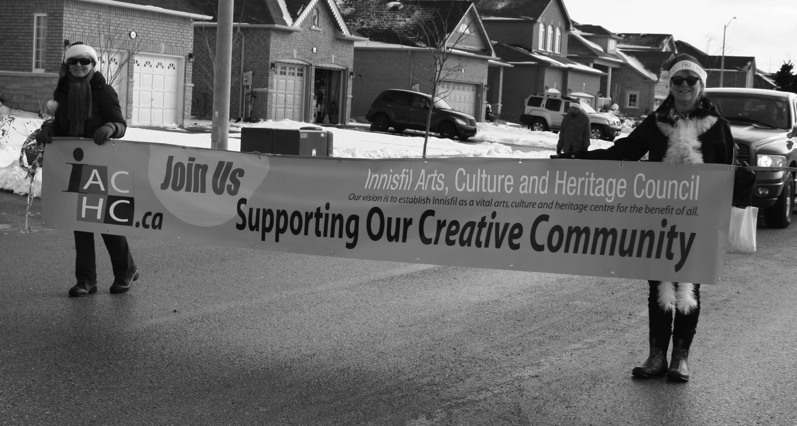
Membership Committee Update December 13th, 2012 Monica Goodfellow
Definition: shall be responsible for developing a wide member base to represent the different areas the council wants to support, and for processing the memberships and keeping the contact and email address lists | Timeline
Goal: Form the committee  - Recruit 3 other members for the Membership committee  - Elect members to the committee at next Meeting of the Membership (4 x year)  - Committee set to work defining goals and strategies for approval of the Executive Committee  - Contact those on the Steering Committee - Membership Committee and invite to join  - Contact other members and invite to volunteers on different standing committees (to generate volunteers for all committees | Completed  December  December  November  November
Goal: Develop a wide membership base  - members encouraged to bring a friend to December Membership Meeting  - Work with PR Committee to generate brochure for committee including copy of the membership form – (on website, Facebook account?) and Membership Drive –we would like this to be modified to be a black and white copy of the poster that Jeanette created for IACHC Monica to Contact Jeanette  - Acknowledge Membership - Issue membership card, phone call welcome (Executive Committee) motion for $50 to buy stamps to send cards in mail (approved November meeting) – Buy stamps, paper, envelopes  - Revise Membership Form to Reflect Definition of Memberships  - Think ahead to when memberships will be paid – how paid, cash cheque, Paypal… notices of membership dues (speak to Treasurer)  (Extend free membership until April – 1 year from Inaugural)  Create a Code of Conduct to be included in the Rules and Regulations  - Conduct a six month membership campaign (Nov–April2013) | December  January  Completed  December  Ongoing  April  April  Present  Ongoing
Goal: Processing the memberships  - Monitor need for creation of a phone tree for membership as numbers grow  - Definition of Memberships – present to Executive Committee/Membership | Ongoing  April
Goal: Keeping the contact and email address list  - Post a list of members on line (if members wanted to be posted on line) and links to other websites as well as a community calendar  - Maintain the Membership list based on new members received and edits to membership information | December  Ongoing
Goal: Demonstrate benefits to membership  - Bylaws and Rules and Regulations available on the web site for member access  - Distribute Minutes of meetings or post on website  - Benefits – attend 4 times year Membership Meetings and vote  (Set meeting dates for next year soon so can notify members)  Attend AGM and vote, Contact info on web site  Offer discounts to other members (add to membership form?) | Completed  Monthly  Completed

IACHC
Communications
December 13th, 2012

Submission: to acknowledge a generous offer from Donna Wice/Innisfil Heritage Society to consider holding our meetings from time to time, at Knock Community Centre, to strengthen our historical partnership.

Innisfil Celtic Festival AGM is next Tuesday the 18th of December, 7pm Town Hall Community Room

Lakeshore Branch Redesign invited IACHC Board members to participate in think-tank workshop for the Lakeshore expansion. Many unified and also unique ideas came forth.

Arrangement of appointment with IT staff for training on website.

Commercial creation on membership, ask Sergio and Erin for time available for their assistance in the New Year to plan under communications committee. Request library to play on display screens.

Updated Facebook page to highlight changes to the committee structure.

